Date | Homework
Monday 10/9 | No School—Columbus Day!
Tuesday 10/10 | Math: 3.8  Phonics: Share Sheet #4
Wednesday 10/11 | Math: 3.9  Phonics: Share Sheet #4
Thursday 10/12 | Math: None  Phonics: Share Sheet #4
Friday 10/13 | Read, Read, Read!!!
Mrs. VanAsdlen’s Weekly Newsletter:
October 9th – 13th

Special Notes!
- Scholastic Book Orders are due on Thursday, October 12th.
- Friday, October 13th Kindergarten will be going on our field trip to Dollinger’s Pumpkin Farm. Please be sure to pack a sack lunch for your child on this day—we are eating at the pumpkin farm!

Phonics:
- Frieze 5- students will recognize, write and know the letter and sounds for /ng/, v, long and short /oo/. Please practice flashcards daily!
- Tricky Words- students will review all tricky words learned thus far.
- Share Sheet #4 will be sent home on Tuesday, October 10th.

STEM:
STEM builds creators, thinkers, problem solvers, doers, innovators, and inventors. Exposing kids to simple STEM ideas at an early age, sets a foundation for higher-level thinking. Donation ideas: Legos, blocks, all things magnetic, straws, cotton balls, popsicle sticks, marbles, rocks, clothespins, plastic cups, Play-doh, toothpicks etc. All donations will be very much appreciated!
** As well as the homework listed above, I encourage your child to study his or her spelling words and dictation sentences on a nightly basis to prepare them for the test. Please also read for at least 20 minutes a day. This helps build their fluency, comprehension and love for reading! **

** As well as the homework listed above, I encourage your child to study his or her spelling words and dictation sentences on a nightly basis to prepare them for the test. Please also read for at least 20 minutes a day. This helps build their fluency, comprehension and love for reading! **

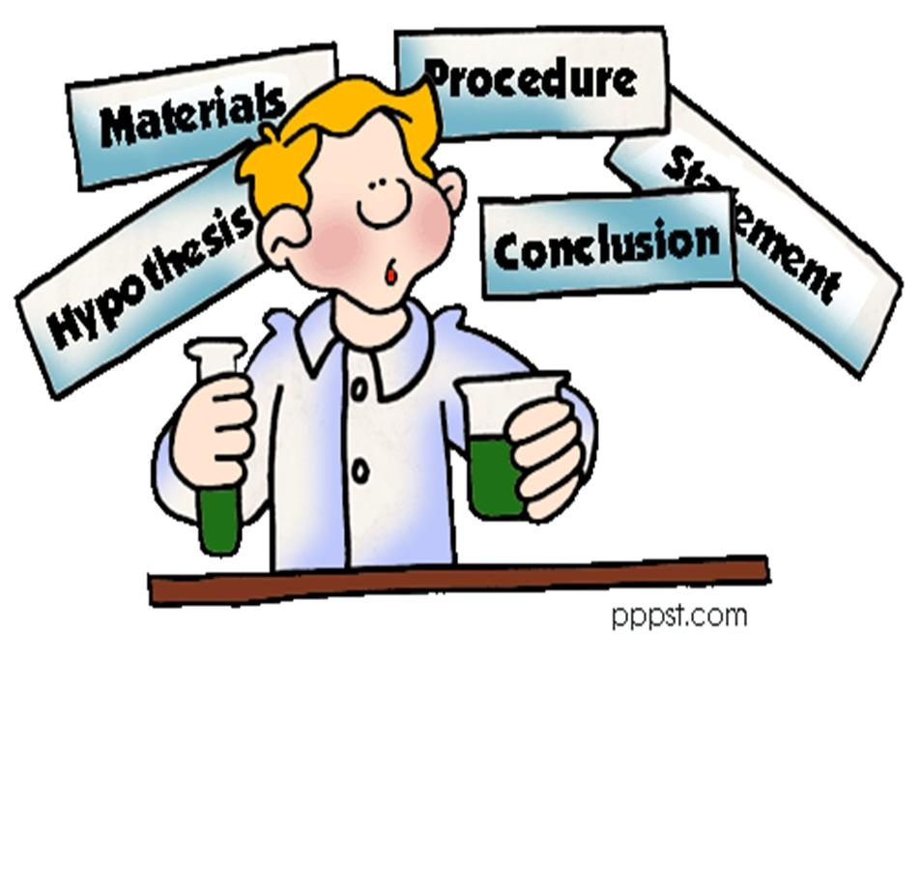
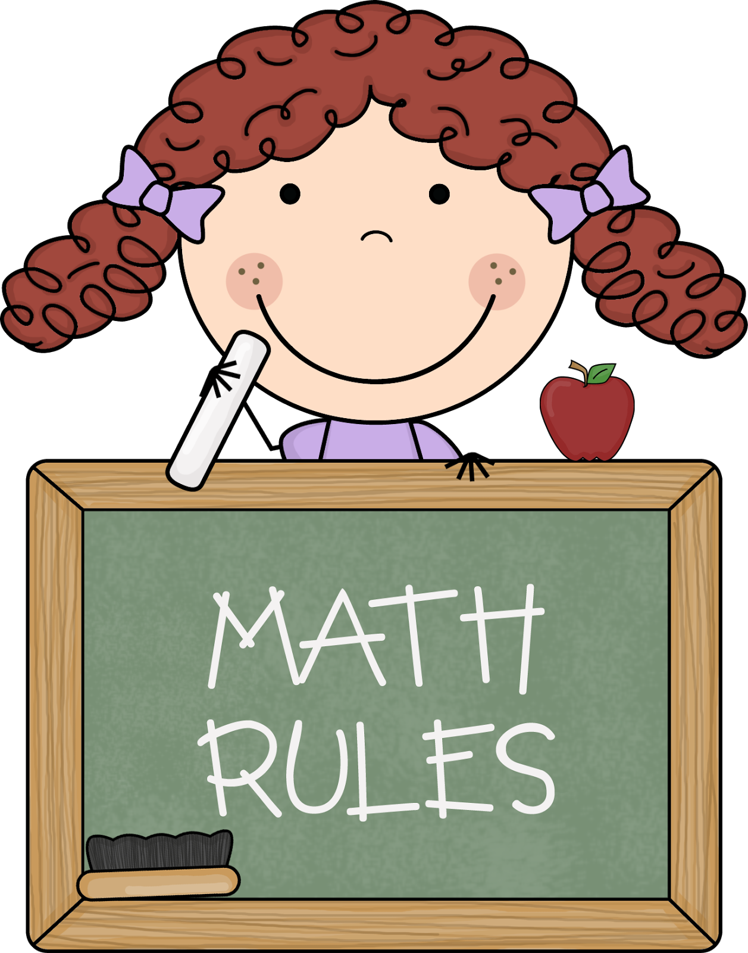
Math
This week we will continue Chapter 3 Represent, Count, and Write Numbers 6-9.
Next week, students will take the Chapter 3 test on Tuesday, October 17th.

** As well as the homework listed above, I encourage your child to study his or her spelling words and dictation sentences on a nightly basis to prepare them for the test. Please also read for at least 20 minutes a day. This helps build their fluency, comprehension and love for reading! **

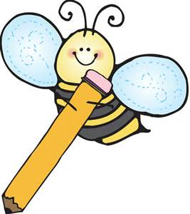
Writing
This week’s themes are Christopher Columbus & pumpkins. We will also begin our science experiment and grow our own pumpkin patch in the classroom!
Upcoming Events:
- 10/13 –Dollinger’s Pumpkin Farm Field Trip
- 10/20 PTO Store & Bux
- 10/23-10/27 –PTO Book Fair
- 10/27 Trunk-or-Treat Parade
- 10/27 5 Hour Day!—Fall Fest @ night
- 10/30 No School
- 10/31 Halloween

Reading Strategy:
Good readers use all different reading strategies; visualizing, retelling, and understanding the characters to better comprehend the text. These strategies will be used while reading the story Leonardo the Terrible Monster..

Contact Mrs. VanAsdlen:
mvanasdlen@min201.org
815.467.2261 ext. 1104

