Date | Homework
Monday 9/18 | Math: 2.5  Phonics: Share Sheet #2
Tuesday 9/19 | Math: None (Ch. 2 Practice Test)  Phonics: Share Sheet #2
Wednesday 9/20 | Math: Study  Phonics: Share Sheet #2 due!
Thursday 9/21 | Math: None (Ch. 2 Test)  Phonics: Share Sheet #3
Friday 9/22 | Read, Read, Read!!!
Mrs. VanAsdlen’s Weekly Newsletter:
September 18th – 22nd

Special Notes!
- Please support our PTO by ordering Marco’s Pizza on Tuesday, September 19th. Give them your child’s name, class (K2) and Minooka Elementary School and your pizza will be delivered in their personally decorated pizza box!
- Johnny Appleseed permission slip is due by Thursday, September 21st!
- PTO is celebrating Jim Henson’s birthday; the creator of the Muppets, by having a Sock Puppet decorating day this Friday. Please have your child bring in one sock to decorate by Thursday, September 21st!
- Friday, September 22nd is a 5 hour day. Dismissal is at 1:35 p.m.
- Dollinger’s Pumpkin Farm field trip permission slip and $6 are due by Friday, September 22nd!

Phonics:
- Frieze 3 students will recognize, write and know the sounds for letters l, f, b. Please practice flashcards daily.
- Tricky Words- students will recognize and spell: be, was These words are “tricky” because they cannot be sounded out.
- Share Sheet #2- Due Wednesday, September 20th.
- Share Sheet #3- Due Thursday, September 28th.

** As well as the homework listed above, I encourage your child to study his or her spelling words and dictation sentences on a nightly basis to prepare them for the test. Please also read for at least 20 minutes a day. This helps build their fluency, comprehension and love for reading! **

** As well as the homework listed above, I encourage your child to study his or her spelling words and dictation sentences on a nightly basis to prepare them for the test. Please also read for at least 20 minutes a day. This helps build their fluency, comprehension and love for reading! **

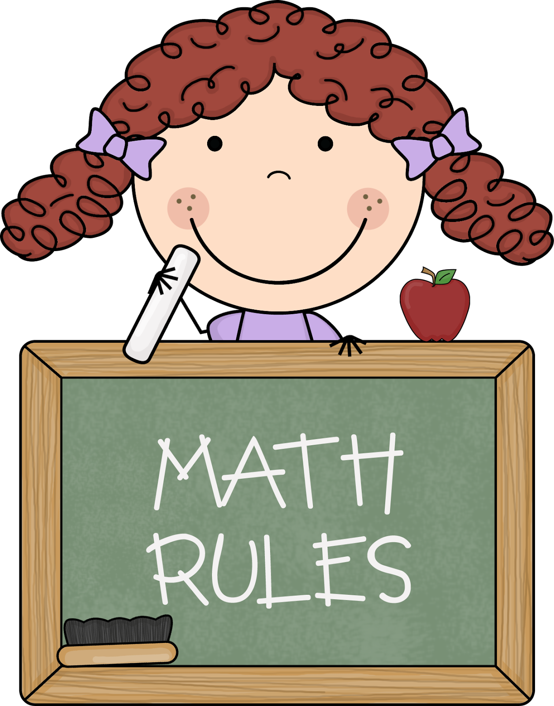
Reading Strategy:
Schema & Background Knowledge
When we explore our background knowledge about a topic, we are able to connect to and better understand what we read.

Math
This week we will continue with the last lesson of this short chapter 2 math book. Thursday, September 21st students will take the Chapter 2 Compare Numbers to 5 test.

** As well as the homework listed above, I encourage your child to study his or her spelling words and dictation sentences on a nightly basis to prepare them for the test. Please also read for at least 20 minutes a day. This helps build their fluency, comprehension and love for reading! **

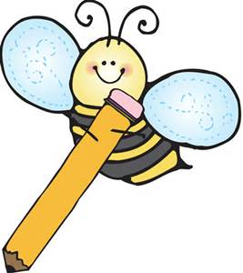
Upcoming Events:
- 9/21- Dad’s Night @ 6:00 p.m.
- 9/22- 5 hour Day! & First Day of Fall
- 9/26- Johnny Appleseed Rotation
- 9/29- PTO Store
- 10/2- Picture Day!
Writing
Continuing with our theme of Apples for the month of September, students will learn our next trait of writing—Organization. Students will be able to sequence the order of how to eat an apple, an apple’s lifecycle, and the seasons of an apple tree.
Contact Mrs. VanAsdlen:
mvanasdlen@min201.org
815.467.2261 ext. 1104

