Date | Homework
Monday 9/4 | NO SCHOOL!
Tuesday 9/5 | Math: 1.10  Phonics: Share Sheet #1
Wednesday 9/6 | Math: None  Phonics: Share Sheet #1 due!
Thursday 9/7 | Math: Study for Chapter 1 math test tomorrow!
Friday 9/8 | Read, Read, Read!
Ms. Reyes’ Weekly Newsletter:
September 4th – 8th

Special Notes!
- Scholastic Book orders are due Thursday, September 7th online or sent to school.
- Please support our school by attending PTO’s Portillo’s Night on September 6th!
- Box Top trade in days for Baxter Bux is on Friday, September 8th! Bring box tops in on the Baxter Bux and receive a buck to use at the school store.
- Next week, 9/1 1-9/15 is our Packing the Piggies collection. Please send any loose change to support our school!

Jolly Phonics:
- Frieze 2- students will recognize, write and know the sounds for letters h, r, m, d. Please practice the letters your child has already learned thus far with the flashcards that were sent home.
- Tricky Words- students will recognize and spell these sight words: he, she (these words are “tricky” because they cannot be sounded out).
- Share Sheet #1- This practice worksheet should be completed 5 times at home. Please return on Wednesday, September 6th.

** As well as the homework listed above, I encourage your child to study his or her spelling words and dictation sentences on a nightly basis to prepare them for the test. Please also read for at least 20 minutes a day. This helps build their fluency, comprehension and love for reading! **

** As well as the homework listed above, I encourage your child to study his or her spelling words and dictation sentences on a nightly basis to prepare them for the test. Please also read for at least 20 minutes a day. This helps build their fluency, comprehension and love for reading! **

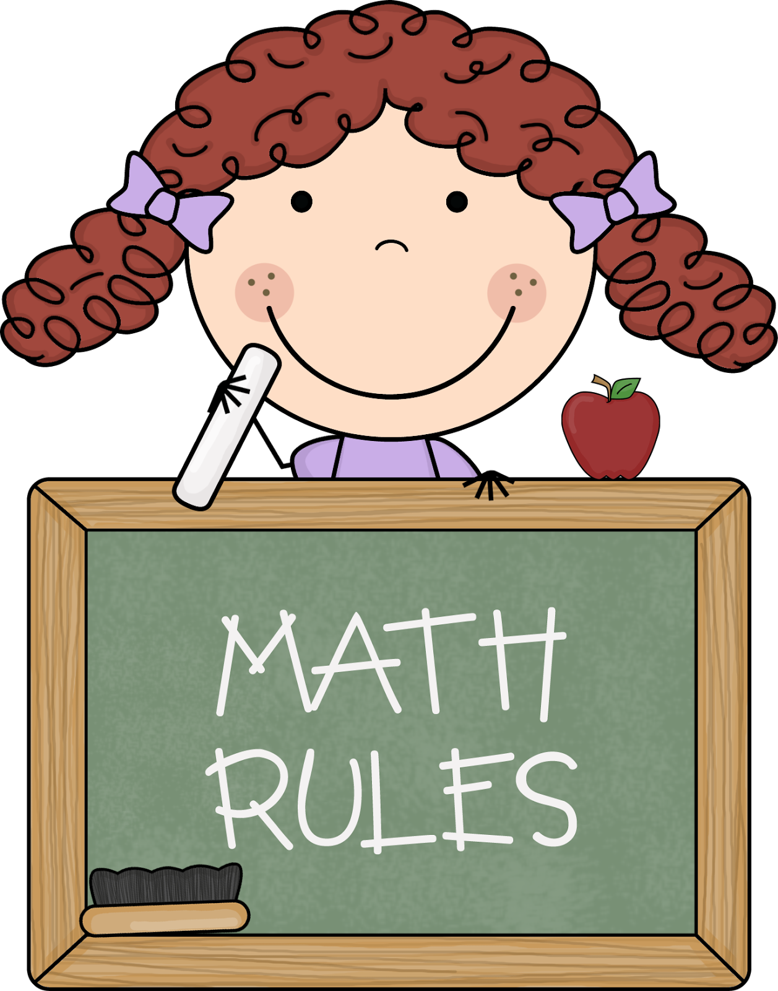
Math
This week students will be taking their first chapter math test on Friday, September 8th. Please study the practice review test your child will bring home on Thursday as it closely relates to the actual test.

Reading Strategy:
Making Predictions: Good readers use the title, pictures, and story words as clues to help them predict what they might read in a book or story.

** As well as the homework listed above, I encourage your child to study his or her spelling words and dictation sentences on a nightly basis to prepare them for the test. Please also read for at least 20 minutes a day. This helps build their fluency, comprehension and love for reading! **

Writing
The beginning of Kindergarten writing is all about inventive spelling. If you have noticed your child labeling or spelling words that are not complete, this is OKAY! Inventive spelling is all about writing the sounds your child hears. Labeling pictures with words is the beginning stage of an independent writer. As your child learns more letter combination sounds, their writing will progress as well!

Upcoming Events:
- 9/4- No school (Labor Day)
- 9/8- Box Tops Bux Turn In
- 9/11– Patriot’s Day celebration
- 9/12- AIMSweb Testing
- 9/22- 5 hour Day! & First Day of Fall
- 9/26- Johnny Appleseed Rotation Day
Contact Mrs. VanAsdlen:
mvanasdlen@min201.org
815.467.2261 ext. 1104

