Date | Homework
Monday 8/28 | Math: 1.5
Tuesday 8/29 | Math: 1.6  Phonics: Share Sheet #1
Wednesday 8/30 | Math: 1.7  Phonics: Share Sheet #1
Thursday 8/31 | Math: 1.8  Phonics: Share Sheet #1
Friday 9/1 | Read, read, read!!
Mrs. VanAsdlen’s Weekly Newsletter:
August 28th-
September 1st

Special Notes!
*I am sorry to have originally mislead you, but our district and principal are really pushing to become paperless as much as we possibly can. Thus, this will be the last newsletter in paper form to be sent home. I will be posting newsletters each Monday on our classroom website http://k2mreyes.weebly.com and in an attached file on the Remind App. If you have not subscribed already, please do so. This will allow communication for each week to be effective. For smartphones, please visit rmd.at/k2bum and it will instruct you to sign up and download the app. Or if you just want to get text notifications, text the number 81010 and send the message: @ k2bum
*This Friday, September 1st is a 5-hour day—dismissal is at 1:35pm. There is also no school on Monday, September 4th.

Reading Strategy:
Choosing Books: Carefully choosing what we read helps us find books that we’ll enjoy!

Jolly Phonics:
- Frieze 1 & 2- students will recognize, write and know the sounds for letters n, c/k
- Tricky Words- students will recognize and spell these sight words: he, she (these words are “tricky” because they cannot be sounded out).
- Share Sheet #1- This practice worksheet should be completed 5 times at home. Please return on Wednesday, September 6th.
** As well as the homework listed above, I encourage your child to study his or her spelling words and dictation sentences on a nightly basis to prepare them for the test. Please also read for at least 20 minutes a day. This helps build their fluency, comprehension and love for reading! **

** As well as the homework listed above, I encourage your child to study his or her spelling words and dictation sentences on a nightly basis to prepare them for the test. Please also read for at least 20 minutes a day. This helps build their fluency, comprehension and love for reading! **

Scholastic Book Orders
Scholastic Book orders are a cheap, convenient way to allow your Kindergarten student to build their library at home and gain a love for reading. The magazines will be sent home this Thursday. Place your order online or by sending a check to school with the order form by Thursday, September 7th.

** As well as the homework listed above, I encourage your child to study his or her spelling words and dictation sentences on a nightly basis to prepare them for the test. Please also read for at least 20 minutes a day. This helps build their fluency, comprehension and love for reading! **

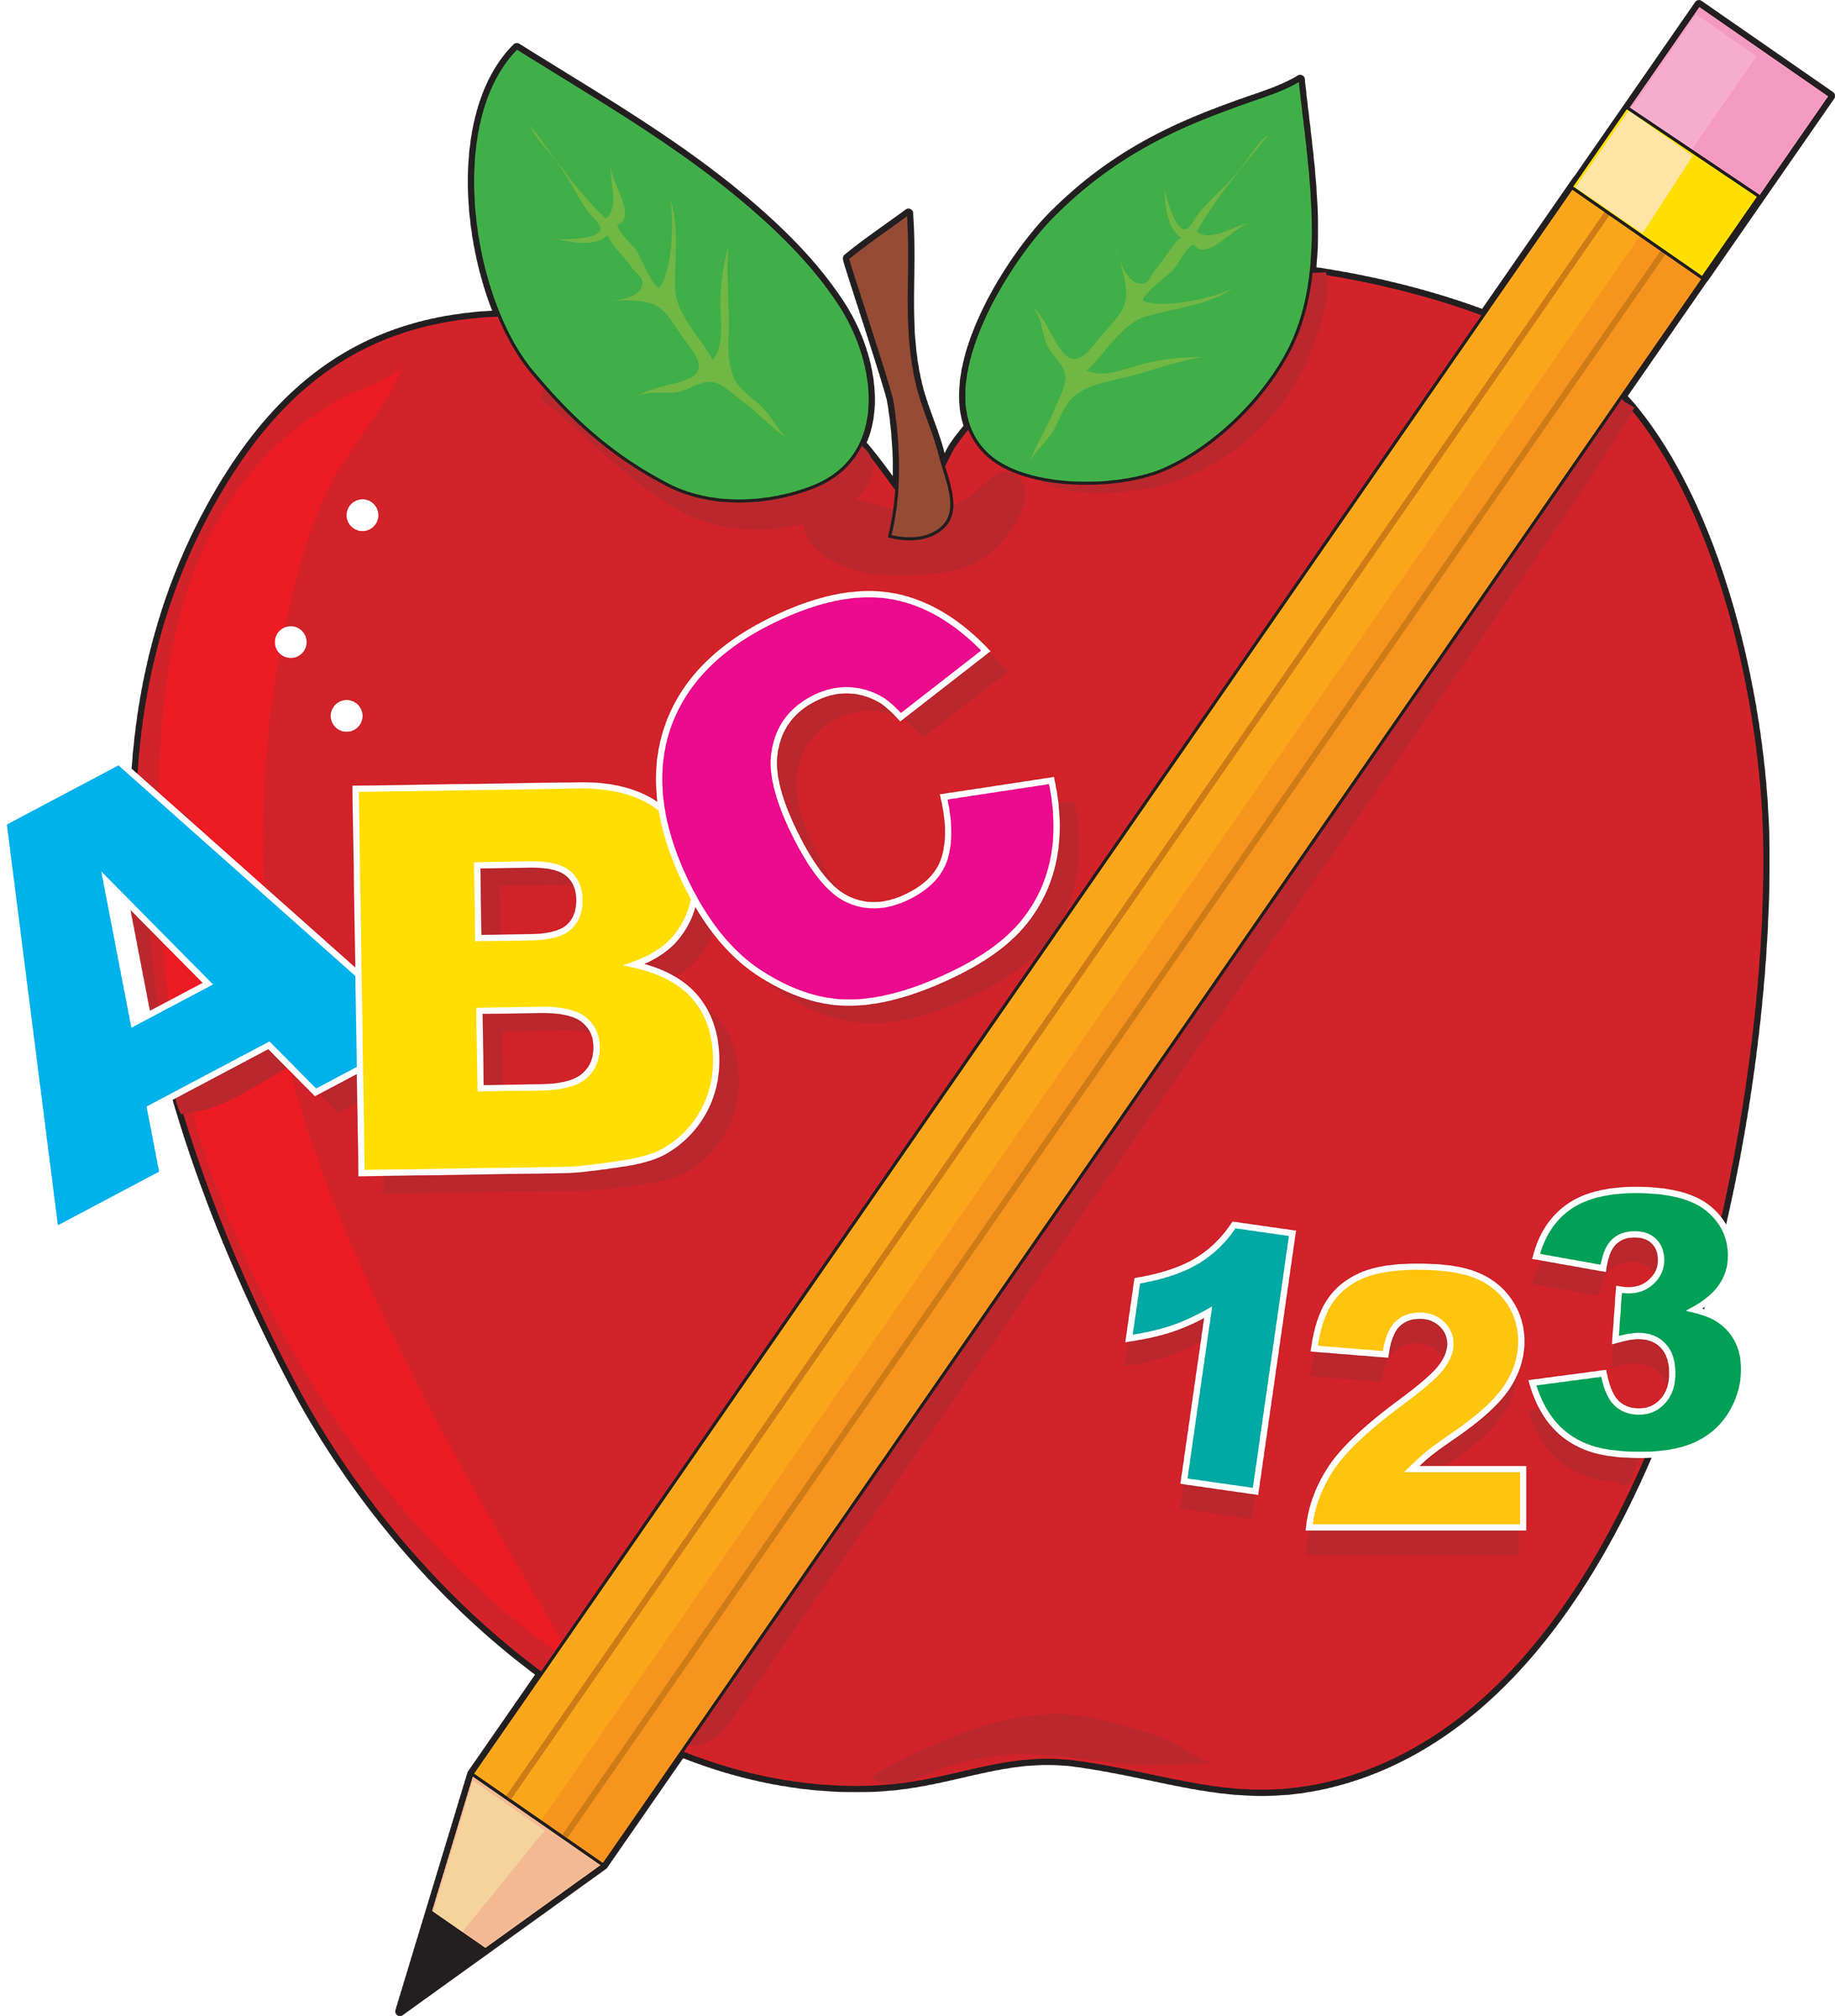
Math
This week we will begin Chapter 1 Represent, Count, and Write Numbers 0-5. As we learn lessons in class, please complete the daily homework each night and return to school the next day. When learning continues at home, your child will be sure to grow!
:
Upcoming Events:
- 9/1 5 hour Day!
- 9/4- No school (Labor Day)
- 9/22 5 hour Day!

Contact Mrs. VanAsdlen:
mvanasdlen@min201.org
815.467.2261 ext. 1104

