Date | Homework
Monday 12/4 | Math: 5.10  Phonics: Share Sheet #7
Tuesday 12/5 | Math: None  Phonics: Share Sheet #7 Due!
Wednesday 12/6 | Math: 5.11  Phonics: None
Thursday 12/7 | Math: 5.12  Phonics: None
Friday 12/8 | Read, Read, Read!!
Mrs. VanAsdlen’s Weekly Newsletter:
December 4th-8th

Special Notes!
- Tuesday, December 5th is the Kindergarten Music Performance from
6-6:30p.m. Please have your child to our classroom by 5:45 p.m. After the concert, you will pick students up from our classroom as well.
- Please visit our classroom website with new updated pictures from our corn experiment and author visit, Amy Logan! https://k2mreyes.weebly.com
- Please read the note about our little elf friend that will be joining our classroom the remainder of this month. Please keep this a secret as students will be surprised on Thursday with our Kindness Elf!

Pizza Hut Reading Coupons
December reading logs will be due after Winter Break!

Phonics:
- Tricky Words- here, there (these words are “tricky” because they cannot be sounded out).
- Share Sheet #7 will be due on Tuesday, December 5th.
- Word Family- short a, -at & -an

** As well as the homework listed above, I encourage your child to study his or her spelling words and dictation sentences on a nightly basis to prepare them for the test. Please also read for at least 20 minutes a day. This helps build their fluency, comprehension and love for reading! **

Reading Strategy:
Inferring & Visualizing
We enrich our understanding of stories by connecting what we already know to what we read and by learning to read “between the lines.”
This week students will use their learned reading strategies in the story Gingerbread Baby.

** As well as the homework listed above, I encourage your child to study his or her spelling words and dictation sentences on a nightly basis to prepare them for the test. Please also read for at least 20 minutes a day. This helps build their fluency, comprehension and love for reading! **

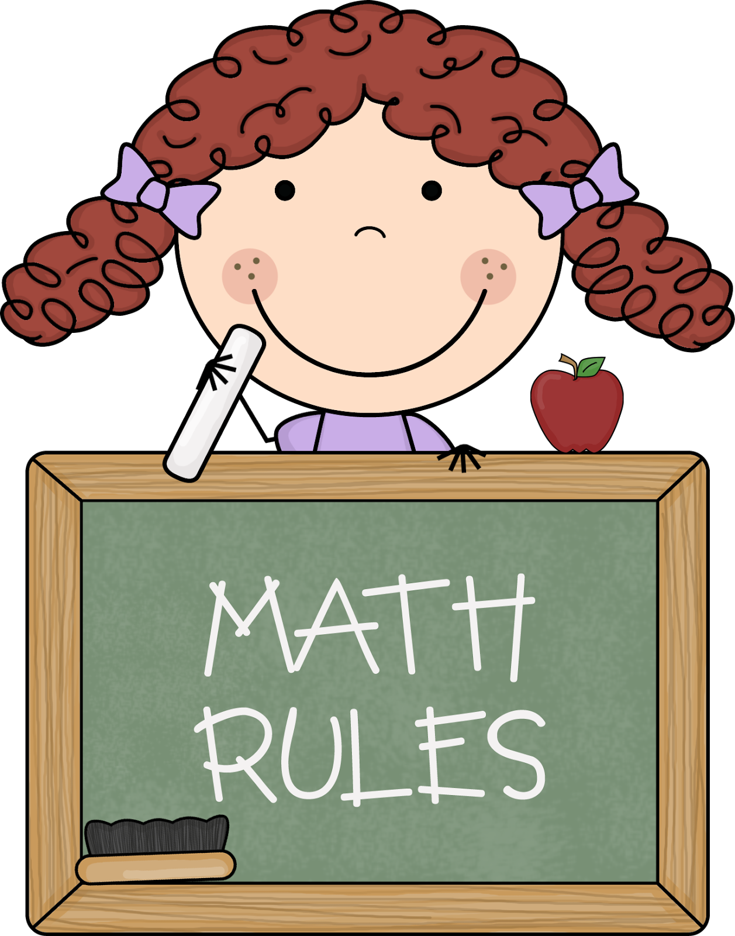
Math
We will continue with Chapter 5 Addition for the remainder of December. We will not begin a new chapter until after winter break. Thus, students will engage in supplemental addition activities after our math book is completed. These lessons will not require any homework to be completed. As of now, our Chapter 5 Addition math test will be taken on December, 15th.

** As well as the homework listed above, I encourage your child to study his or her spelling words and dictation sentences on a nightly basis to prepare them for the test. Please also read for at least 20 minutes a day. This helps build their fluency, comprehension and love for reading! **

Writing
Our writing unit will focus on how to make good word choices when we are writing. Students will learn how to use adjectives to describe nouns.
We will also continue writing sentences in our writing journals.
Contact Mrs. VanAsdlen:
mvanasdlen@min201.org
815.467.2261 ext. 1104

Upcoming Events:
- 12/5- Kindergarten Music Program @ 6:00p.m.
- 12/15- PTO Store
- 12/22- 5 Hour Day!-PTO’s Winter Celebration
- 12/23-1/8—WINTER Break!

