Date | Homework
Monday 11/13 | Math: 5.2  Phonics: Share sheet #6
Tuesday 11/14 | Math: 5.3  Phonics: Share sheet #6
Wednesday 11/15 | Math: 5.4  Phonics: Share Sheet #6
Thursday 11/16 | Math: 5.5  Phonics: Share Sheet #6 due!
Friday 11/17 | Read, Read, Read!
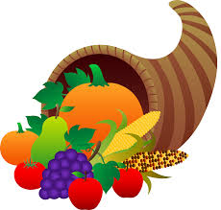
Mrs. VanAsdlen’s Weekly Newsletter:
November 13th – 17th

Special Notes!
- First off, I would like to thank our families for making our Disguise a Turkey project so successful. I personally thank you for all your hard work. I hope you enjoyed it as much as I have! –Pictures are on our classroom website!
- Scholastic Book orders will be due by Friday, November 17th.
- Kindergarten’s report cards will be available on TeacherEase on Friday, November 17th for the first trimester. Any questions can be discussed at your child’s conference time next week!
- Parent Teacher Conferences are next week; Monday, Nov. 20th & Tuesday, Nov. 21st. The remainder of the week there is no school.
HAPPY THANKSGIVING! Gobble, Gobble!

Phonics:
- We have completed all Jolly Phonics letters and sounds- we will continue to practice the letters/sounds learning daily.
--Please practice flashcards!
- Tricky Words- students will recognize and spell: some, come (these words are “tricky” because they cannot be sounded out).
- Share Sheet #6 will be due on Thursday, November 16th.

** As well as the homework listed above, I encourage your child to study his or her spelling words and dictation sentences on a nightly basis to prepare them for the test. Please also read for at least 20 minutes a day. This helps build their fluency, comprehension and love for reading! **

** As well as the homework listed above, I encourage your child to study his or her spelling words and dictation sentences on a nightly basis to prepare them for the test. Please also read for at least 20 minutes a day. This helps build their fluency, comprehension and love for reading! **

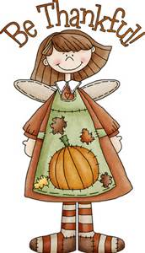
Manners Matter
Our social/emotional focus for this month is Gratefulness.

Reading Strategy:
Good readers use all different reading strategies to better understand the text. This week students will use their learned reading strategies in the story A Turkey for Thanksgiving.

Monthly Reading Log
Continue reading at home to color in the leaves on your child’s November reading log. Students who return them by November 30th will receive one free personal pan pizza coupon to Pizza Hut.

** As well as the homework listed above, I encourage your child to study his or her spelling words and dictation sentences on a nightly basis to prepare them for the test. Please also read for at least 20 minutes a day. This helps build their fluency, comprehension and love for reading! **

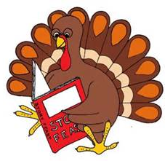
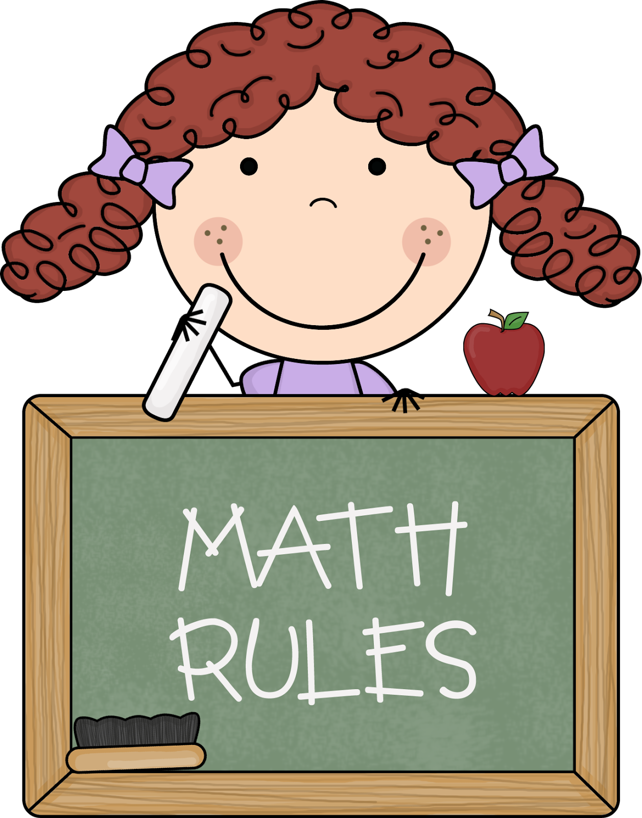
Math
Students will continue learning Chapter 5 Addition.

Upcoming Events:
- 11/17 -End of Trimester 1 (Report Cards Available on TeacherEase)
- 11/20 & 11/21 –PT Conferences
- 11/22-11/24 –Thanksgiving Break!
- 11/30 –Fire, Fire Cindy!

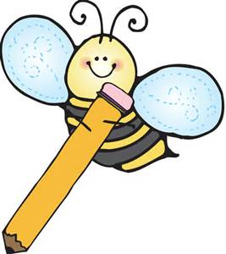
Writing
Our writing theme this week will focus on harvesting, corn, Thanksgiving, Pilgrims and Native Americans. Also, as a part of our science implementation, students will begin a new experiment to find which environment Indian corn can grow best in.
Contact Mrs. VanAsdlen:
mvanasdlen@min201.org
815.467.2261 ext. 1104

