Date | Homework
Monday 11/6 | Math: Study for Ch. 4 Test
Tuesday 11/7 | Math: Chapter 4 Test!
Wednesday 11/8 | Math: None  Disguise a Turkey Due!
Thursday 11/9 | Math: 5.1  Phonics: Share Sheet #6
Friday 11/10—5 Hour Day! | Read, Read, Read!
Mrs. VanAsdlen’s Weekly Newsletter:
November 6th – 10th

Special Notes!
- Disguise a Turkey projects are due on Wednesday, November 8th. Please allow your child to use their creative brains and disguise their turkeys! Families are welcome to help—remember NO food items please!
- MES will be hosting a Veteran’s Day Assembly at 8:50 a.m. on Friday, November 10th. Kindergarten will be singing the Coast Guard Song and handing out homemade flags to veterans that attend.
- Parent teacher conferences will be held November 20th and 21st. Last week a note went home containing your child’s scheduled date and time, if you are unable to attend that time, please let me know so we can reschedule.

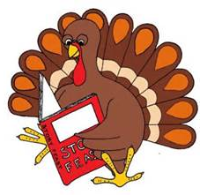

Phonics:
- Frieze 7- students will recognize, write and know the sounds for ue, er, ar. Please practice flashcards daily!
- Tricky Words- students will recognize and spell: they (these words are “tricky” because they cannot be sounded out).
- Share Sheet #6 will be sent home on Thursday.

** As well as the homework listed above, I encourage your child to study his or her spelling words and dictation sentences on a nightly basis to prepare them for the test. Please also read for at least 20 minutes a day. This helps build their fluency, comprehension and love for reading! **

** As well as the homework listed above, I encourage your child to study his or her spelling words and dictation sentences on a nightly basis to prepare them for the test. Please also read for at least 20 minutes a day. This helps build their fluency, comprehension and love for reading! **

Reading Strategy:
Good readers use all different reading strategies; visualizing, retelling, inferencing and using their background knowledge/schema to better understand the text. This week students will use those reading strategies in the story White Owl, Barn Owl.
Math
On Tuesday, November 7th, students will take the Chapter 4 test. Following, students will begin Chapter 5 Addition.

** As well as the homework listed above, I encourage your child to study his or her spelling words and dictation sentences on a nightly basis to prepare them for the test. Please also read for at least 20 minutes a day. This helps build their fluency, comprehension and love for reading! **

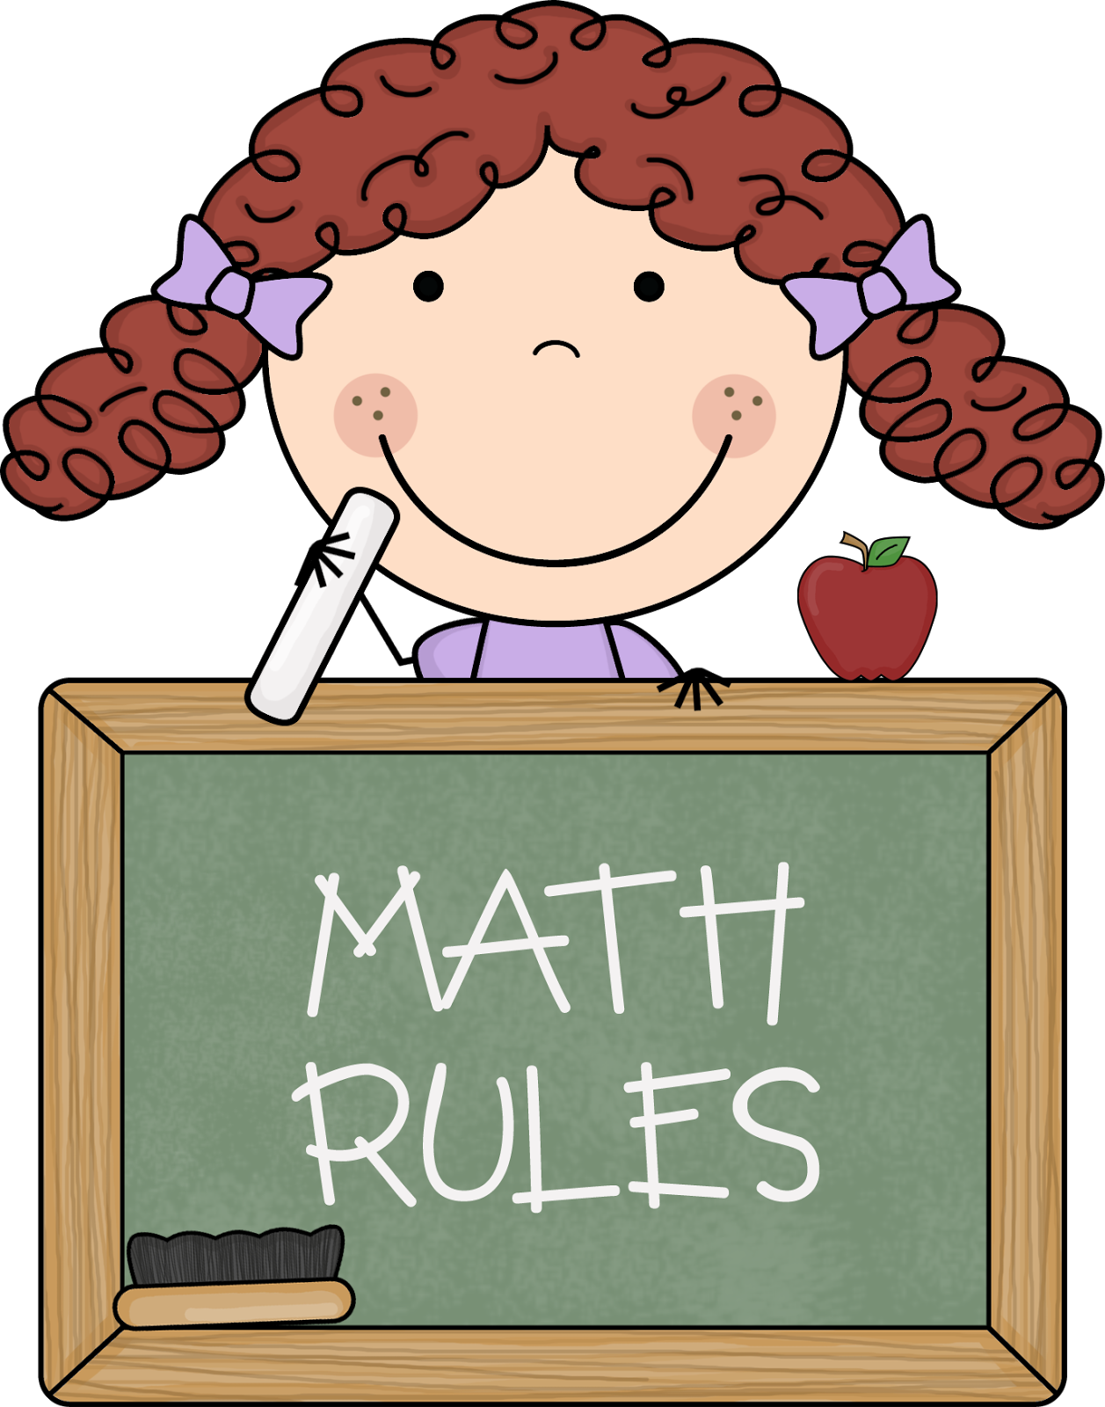
Upcoming Events:
- 11/10- Veteran’s Day Assembly-5 hour day!
- 11/17 -End of Trimester 1 (Report Cards Available on TeacherEase)
- 11/20 & 11/21 –PT Conferences
- 11/22-11/24 –Thanksgiving Break!
- 11/30 –Fire, Fire Cindy!

Writing
Students will learn about why we celebrate Veteran’s Day and prepare for the assembly on Friday. Students will also be presenting their Disguise a Turkey project and complete a sequencing writing assignment about how they made their turkeys.
Contact Mrs. VanAsdlen:
mvanasdlen@min201.org
815.467.2261 ext. 1104

